1. Adminstraion
- http://highereducation.cg.gov.in/
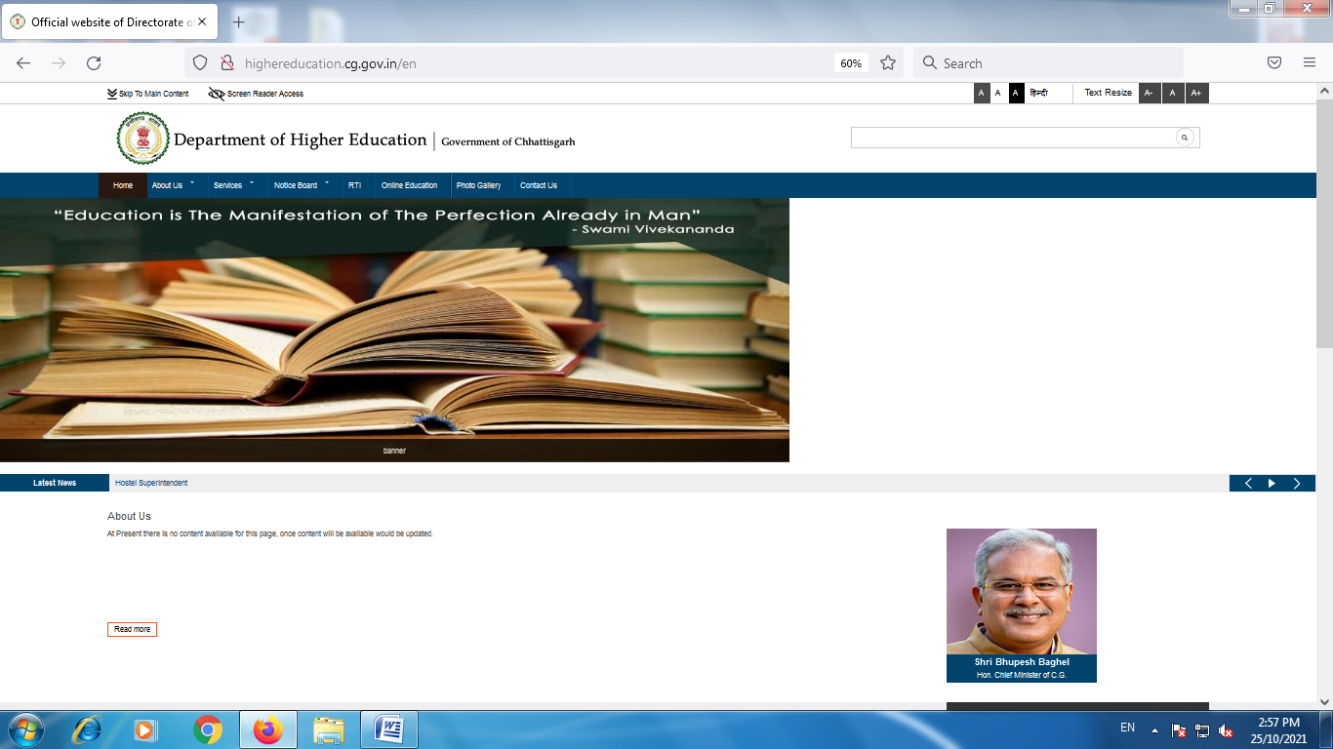
https://mail.google.com/mail/u/0/#inbox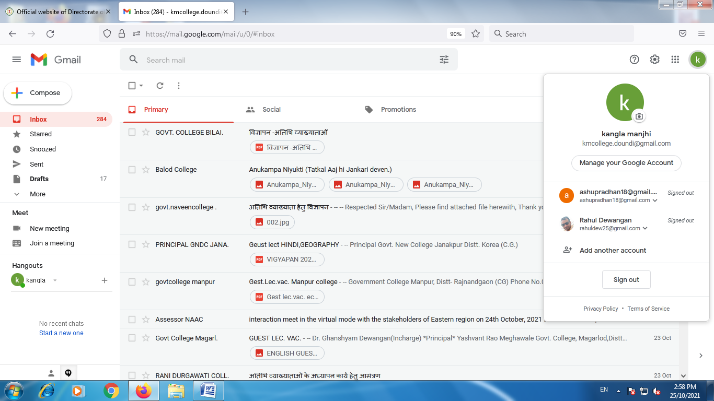
B) http://www.govtkmcollegedondi.com/
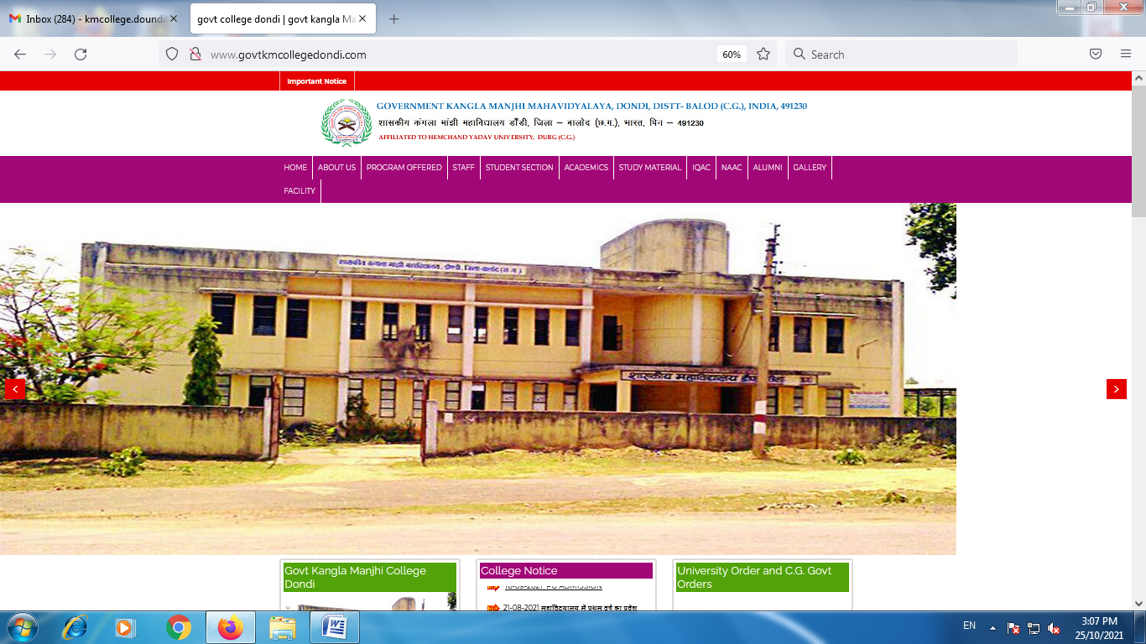

2. Finance and Accounts
https://ekoshonline.cg.nic.in/

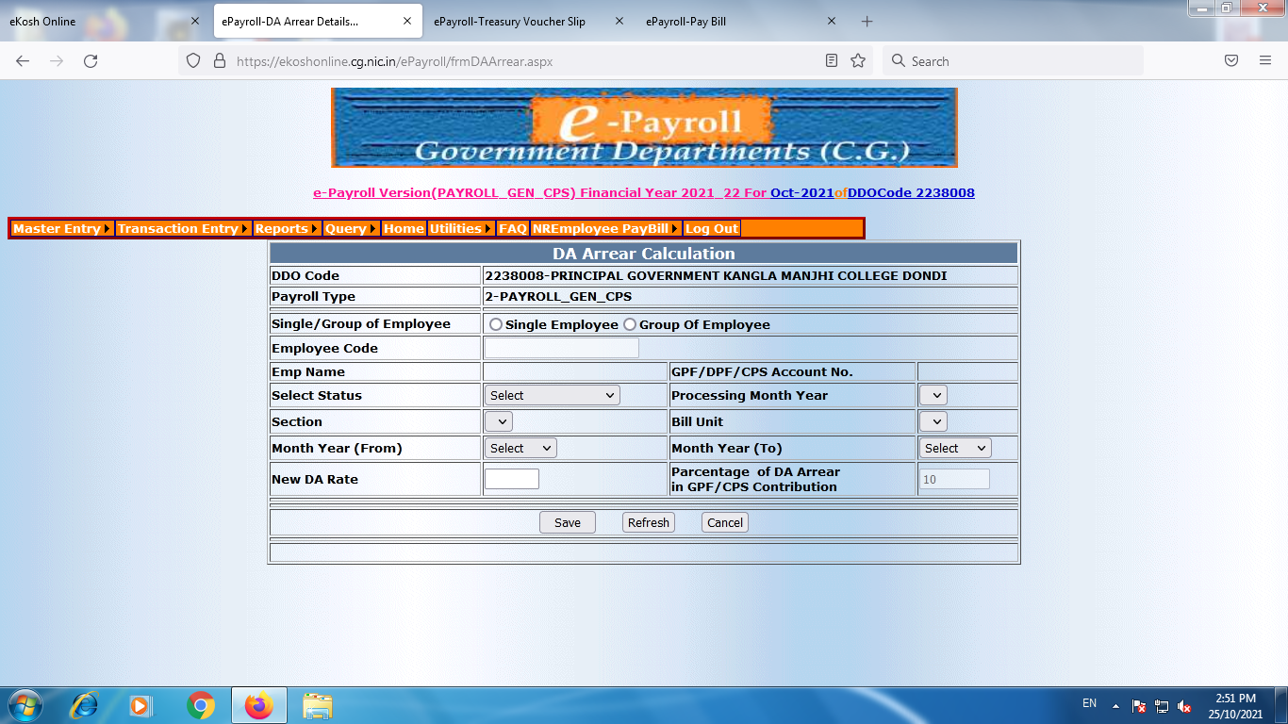
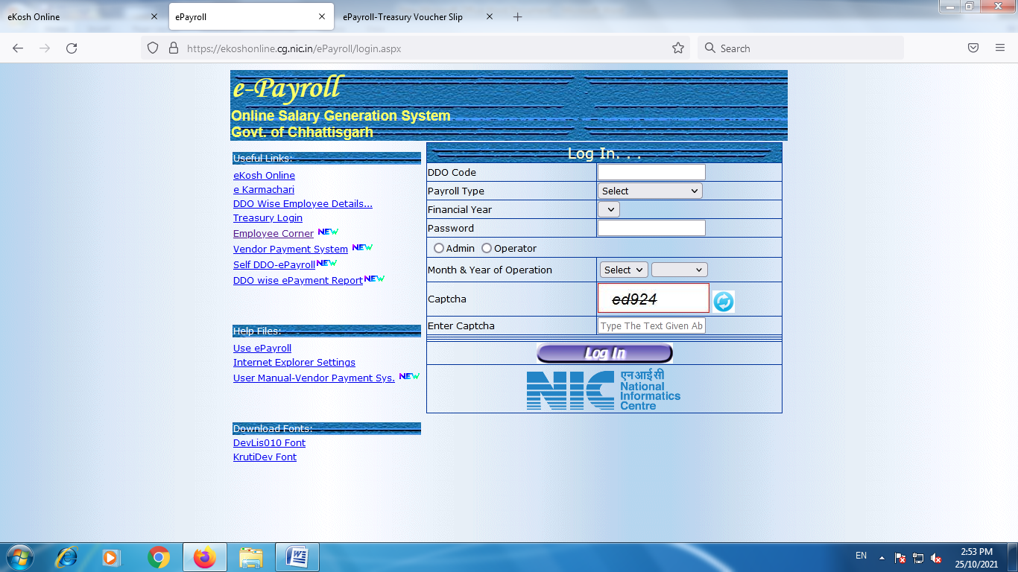

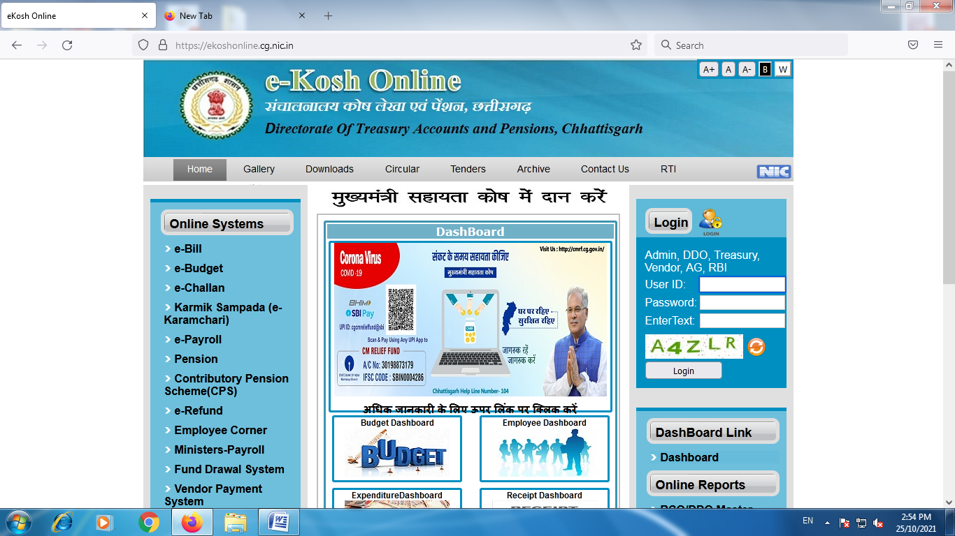
B) http://mpsc.mp.nic.in/cgpms/InstituteAdmin/Public/IA_main.aspx

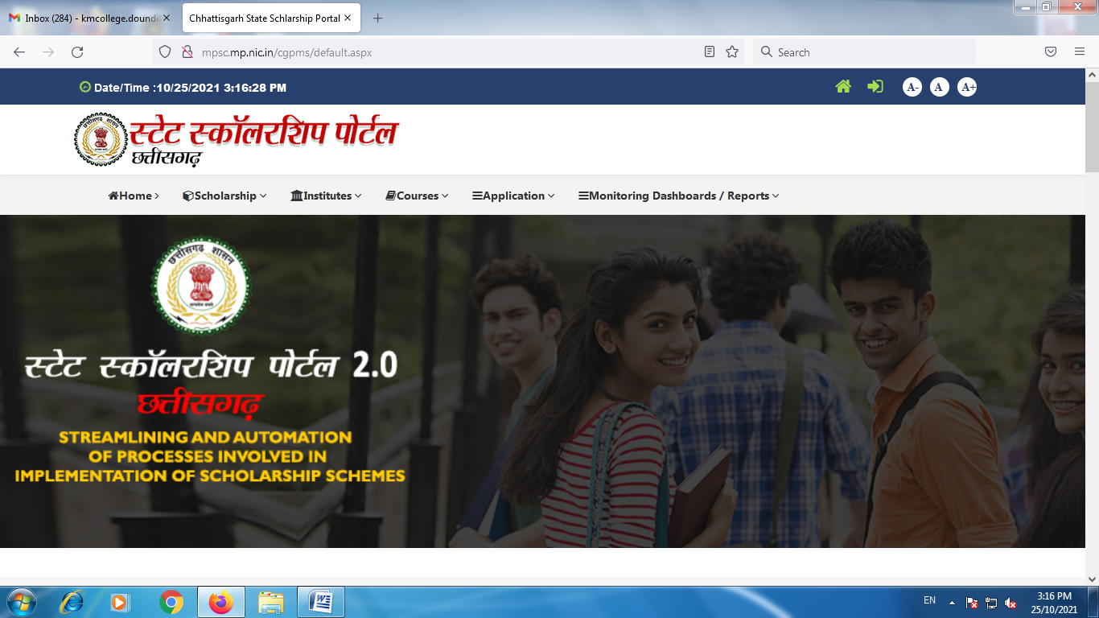
3. Student Admission & Support

https://durg1.ucanapply.com/univer/public/secure?app_id=UElZMDAwMDAyOA==
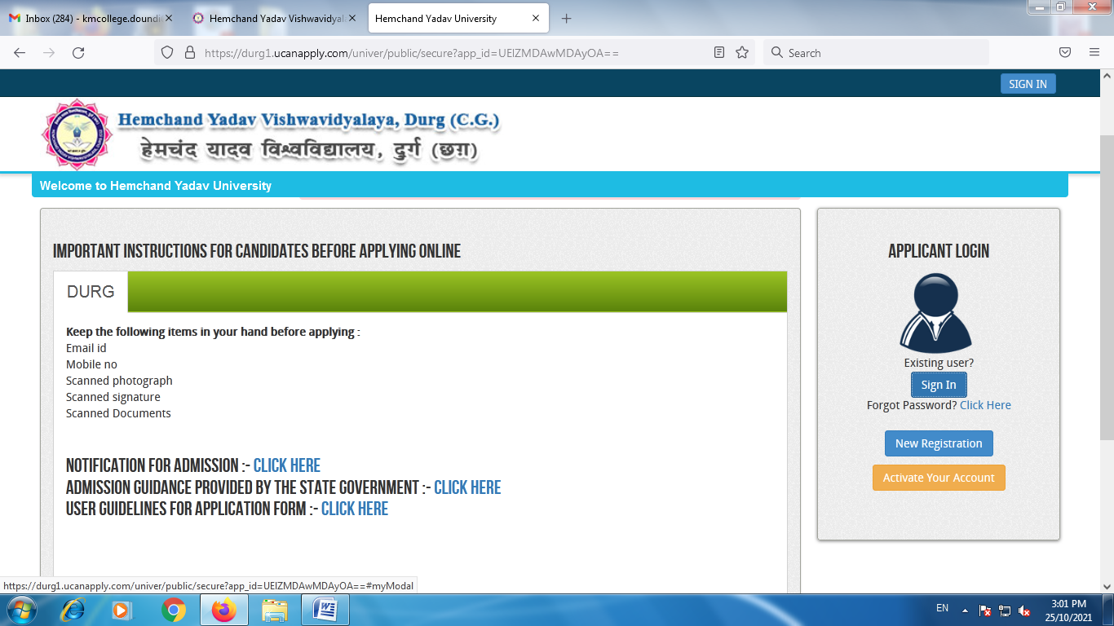
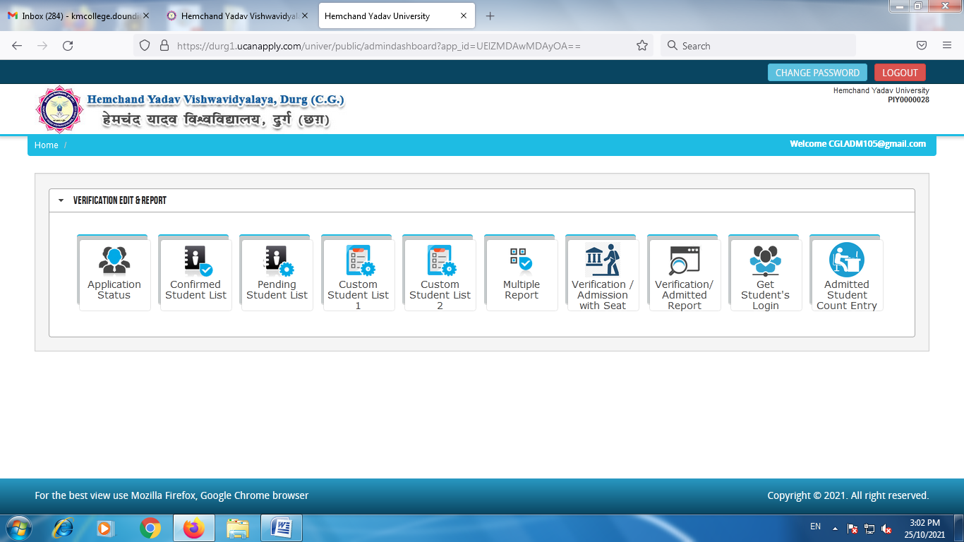
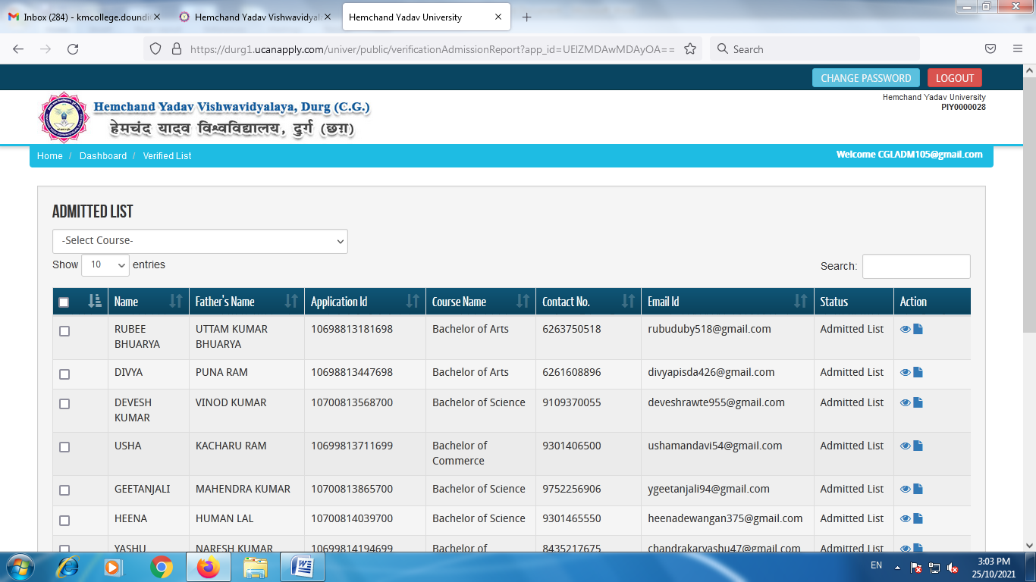

4. Examinations

https://durg.ucanapply.com/smartexam/public/college/dashboard
